

Heritage Open Days is England's largest festival of history and culture, bringing together over 2,000 organisations, 5,000 events and 40,000 volunteers. Every year in September, places across the country throw open their doors to celebrate their heritage, community and history. It’s your chance to see hidden places and try out new experiences – and it’s all FREE.

To find out more go to:

[www.heritageopendays.org.uk](http://www.heritageopendays.org.uk)



Image: Chris Lacey

**Icon Key**



Disabled parking

Fully accessible

Toilets

Hearing loop

Parking

Sign

Baby changing

Disabled toilets



Not normally open

Pushchair friendly

**‘Add location here’**



**EXAMPLE MAIL MERGE FORMATTING**

«PropertyEvent_Name»

«Address_1», «Address_2», «Town», «County», «Postcode»

«Quick_summary»

Friday 10th: «Opening_Times_Friday_1»

Saturday 11th: «Opening_Times_Saturday_1»

Sunday 12th: «Opening_Times_Sunday_1»

Monday 13th: «Opening_Times_Monday_1»

Tuesday 14th: «Opening_Times_Tuesday_1»

Wednesday 15th: «Opening_Times_Wednesday_1»

Thursday 16th: «Opening_Times_Thursday_1»

Friday 17th: «Opening_Times_Friday_2»

Saturday 18th: «Opening_Times_Saturday_2»

Sunday 19th: «Opening_Times_Sunday_2»

Booking details: «Booking_telephone»/«Booking_email»/«Booking_website»



Welcome to England’s largest heritage festival, taking place

10-19 September, at thousands of places across the country. Join 46,400 volunteers in celebrating local places and stories and explore the multitude of familiar and hidden places on your doorstep, completely free of charge.

Check out our easy-to-use online directory to find out what’s happening near you www.heritageopendays.org.uk/directory

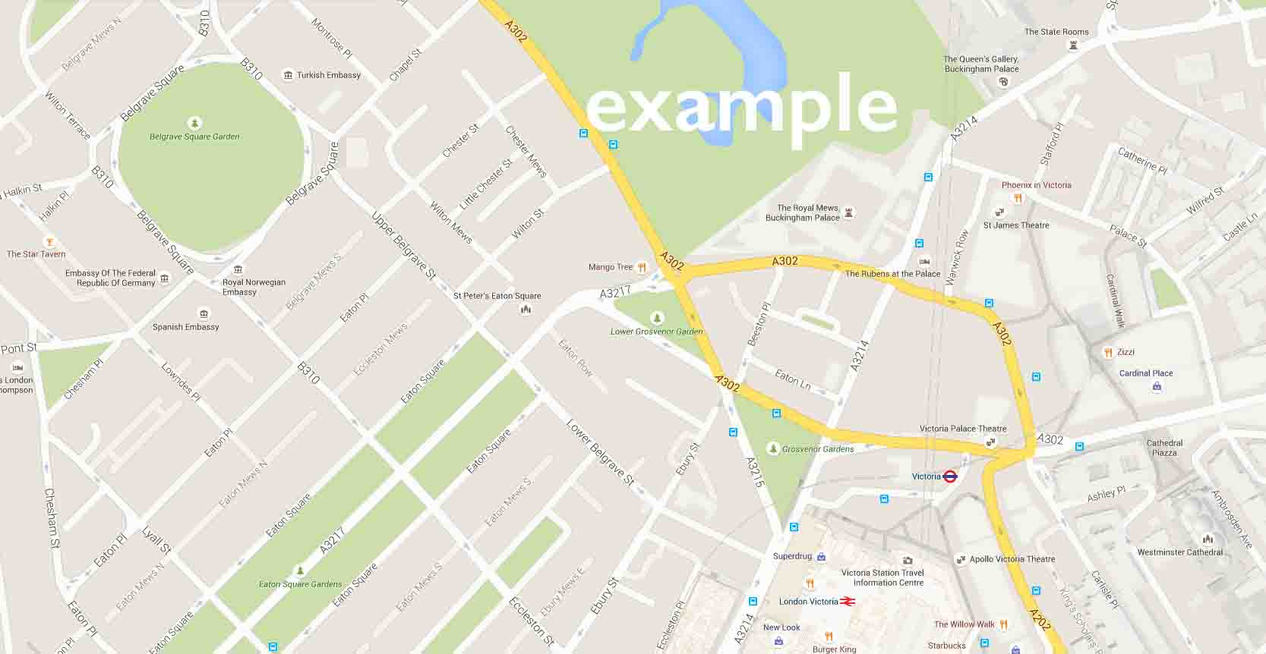



Copy/paste next event text here



Image Caption/copyright/photographer

**NEXT EVENT**

«Next Record»«PropertyEvent_Name»

«Address_1», «Address_2», «Town», «County», «Postcode»

«Quick_summary»

Friday 10th: «Opening_Times_Friday_1»

Saturday 11th: «Opening_Times_Saturday_1»

Sunday 12th: «Opening_Times_Sunday_1»

Monday 13th: «Opening_Times_Monday_1»

Tuesday 14th: «Opening_Times_Tuesday_1»

Wednesday 15th: «Opening_Times_Wednesday_1»

Thursday 16th: «Opening_Times_Thursday_1»

Friday 17th: «Opening_Times_Friday_2»

Saturday 18th: «Opening_Times_Saturday_2»

Sunday 19th: «Opening_Times_Sunday_2»

Booking details: «Booking_telephone»/«Booking_email»/«Booking_website»



­

Copy/paste next event text here



Image: Chris Lacey

Image: Chris Lacey



Copy/paste next event text here

Copy/paste next event text here

Insert Event Text Here

Copy/paste next event text here



Image: Chris Lacey

Image: Chris Lacey



Image: Chris Lacey

Image: Chris Lacey